Unveiling the Future
preparing for what is coming
towards us
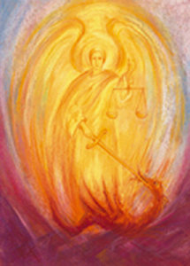

Michaelmas Conference
October 4 – 6, 2019

Friday, October 4, 7:30 P.M.
Through
Sunday, October 6 at 2:00 P.M.

The Christian Community
10030 Fair Oaks Blvd. Fair Oaks, CA 96528

with Liz Beaven, Ed.D, David Gershan, MD
Revs. Rafal Nowak,
Erk Ludwig, Sanford Miller

We live in rapidly changing times with the unexpected becoming the norm. The developments in all areas of human existence from natural science to social policy become harder and harder to keep up with. While some may be a boon for us, others only masquerade as such. Our intention and hope is to begin to more clearly sense the future and thereby strengthen ourselves for whatever is coming towards us, cultivating a living relationship to the Christ, who is revealed to us through the great Archangel Micha-el.

Conference fee: $50-$75
Registration at our website: ccsac.org
No one should stay away for lack of funds!
Included in the conference fee is a vegetarian supper on Saturday evening.

