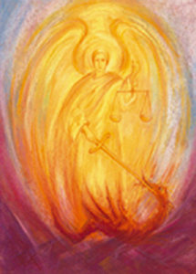
Unveiling the Future
Preparing for what is coming towards us
October 4 – 6, 2019
FRIDAY
6-7:15 pm Registration

7:30 pm "The Other Angel of the Other Apocalypse. Michael’s Initiative for Mankind”
Talk by Rev. Rafal Nowak

SATURDAY

9:00 am The Act of Consecration of Man

10:15 am “Facing the Future of Healing: thoughts from Anthroposophic Medicine and The Pastoral-Medical Course”
Talk by David Gershan, MD

11:45 am Artistic Activity!

1:00 pm – 2:30 pm Lunch Break

2:30 – 3:15 p.m. Conversation groups

3:45 pm “Sun, Moon, and Stars and the Womb of Suffering”
Talk by Rev. Sanford Miller

5:00 pm Artistic Activity

6:00 pm Vegetarian Supper

7:30 pm “Childhood in Crisis: How should schools respond?”
Talk by Liz Beaven, EdD

SUNDAY

10 am The Sunday Service for Children
10:30 am The Act of Consecration of Man
12:00 pm “We are called upon to transform the Earth.” Novalis
Talk by Rev. Erk Ludwig

We live in rapidly changing times with the unexpected becoming the norm. The developments in all areas of human existence from natural science to social policy become harder and harder to keep up with. While some may be a boon for us, others only masquerade as such. Our intention and hope is to begin to more clearly sense the future through talks, conversation and artistic activity and thereby strengthen ourselves for whatever is coming towards us, cultivating a living relationship to the Christ, who is revealed to us through the great Archangel Micha-el.

Conference fee: $50 - $75
Included in the conference fee is a vegetarian supper on Saturday evening.
Registration at our website: ccsac.org, click on “Unveiling the Future”
Information: 916-548-4224
Housing:
Rosalie Parker, 916-825-6418
No one should stay away for lack of funds!

The Christian Community, 10030 Fair Oaks Blvd, Fair Oaks, CA

